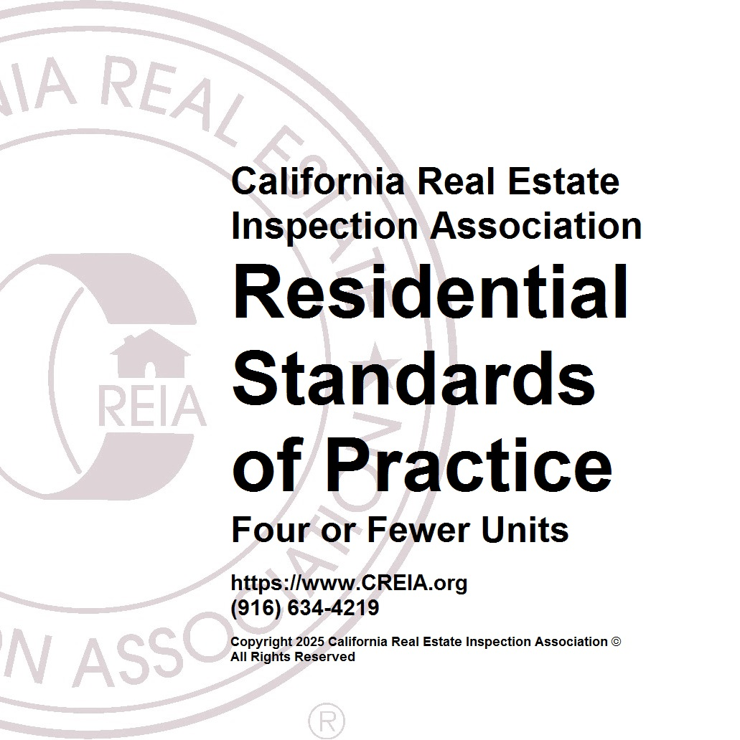
California Real Estate Inspection Association
Residential Standards of Practice - Four or Fewer Units

Part I. Definitions and Scope
These Standards of Practice provide guidelines for a home inspection and define certain terms relating to these inspections. Italicized words in these Standards are defined in Part IV, Glossary of Terms.

A home inspection is a noninvasive, visual survey and basic operation of the accessible systems and components of a home, which can be reached, entered, or viewed without difficulty, moving obstructions, or requiring any action which will result in damage to the property or personal injury to the Inspector. The purpose of the inspection is to provide the Client with information regarding the general condition of the building(s) to assist client in determining what corrections or further evaluations the Client should have corrected, evaluated, or obtain estimates for repair prior to the release of contingencies.

A home inspection report provides written documentation of material defects discovered in the inspected building’s systems and components which, in the opinion of the Inspector, are safety hazards, are not functioning properly, or appear to be at the ends of their service lives. The report will include the Inspector's recommendations for correction or further evaluation. Client should consider all available information when negotiating regarding the Property. Inspections performed in accordance with these Standards of Practice are not technically exhaustive and shall apply to the primary building and its associated primary parking structure.
Cosmetic and aesthetic conditions shall not be considered as stated in CA Business and Professions Code 7195(b).

Part II. Standards of Practice

A home inspection includes the readily accessible systems and components or a representative number of multiple similar components listed in Sections 1 through 10 subject to the limitations, exceptions, and exclusions in each section and in Part III.

SECTION 1 - Foundation, Basement, and Under-floor Areas
- Items to be inspected
  - Foundation
  - Floor framing system
  - Under-floor ventilation
  - Foundation anchoring
  - Cripple wall bracing
  - Wood separation from soil
  - Insulation

- The Inspector is not required to:
  - Determine size, spacing, location, or adequacy of foundation bolting/bracing components or reinforcing systems
  - Determine the composition or energy rating of insulation materials

SECTION 2 - Exterior
- Items to be inspected/reported:
  - Surface grade directly adjacent to the building
  - Doors and windows
  - Attached decks, porch, balconies
  - Stairways that are attached to the building, attached decks, or porch
  - Wall cladding and trim
  - Portions of patios, walkways, and driveways that are adjacent to the building

- The Inspector is not required to
  - Inspect door or window screens, shutters, awnings, or security bars
  - Inspect fences or gates, or operate automated door or gate openers or their safety devices
  - Use a ladder to inspect systems or components
SECTION 3 - Roof Covering
- Items to be inspected/reported:
  - Covering
  - Drainage
  - Flashings
  - Penetrations
  - Skylights

- The Inspector is not required to:
  - Walk on the roof surface if in the opinion of the Inspector there is risk of damage or a hazard to the Inspector
  - Warrant or certify that roof systems, coverings, or components are free from leakage

SECTION 4 - Attic Areas and Roof Framing
- Items to be inspected/reported:
  - Framing
  - Ventilation
  - Insulation

- The Inspector is not required to:
  - Inspect mechanical attic ventilation systems or components
  - Determine the composition or energy rating of insulation materials

SECTION 5 - Plumbing
- Items to be inspected/reported:
  - Water supply piping
  - Drain, waste, and vent piping
  - Faucets, toilets, sinks, tubs, and showers
  - Fuel gas piping
  - Water heaters

- The Inspector is not required to:
  - Fill any fixture with water, inspect overflow drains or drain-stops, or evaluate backflow devices, waste ejectors, sump pumps, or drain line cleanouts
  - Inspect or evaluate water temperature, balancing devices, temperature fluctuation, time to obtain hot water, water circulation, or solar heating systems or components
  - Inspect whirlpool baths, steam showers, or sauna systems or components
  - Inspect fuel tanks or determine if the fuel gas system is free of leaks
  - Inspect wells or water treatment systems

SECTION 6 - Electrical
- Items to be inspected/reported:
  - Service equipment
  - Electrical panels
  - Circuit wiring
  - Switches, receptacles, outlets, and lighting fixtures

- The Inspector is not required to:
  - Operate circuit breakers or circuit interrupters
  - Remove cover plates
  - Inspect de-icing systems or components
  - Inspect onsite, photovoltaic, or emergency electrical generation or electrical storage systems or components

SECTION 7 - Heating and Cooling
- Items to be inspected/reported:
  - Heating equipment
  - Gas venting
  - Central cooling equipment
  - Energy source and connections
  - Combustion air and exhaust vent systems
  - Condensate drainage
  - Conditioned air distribution systems

- The Inspector is not required to:
  - Inspect heat exchangers or electric heating elements
  - Inspect non-central air conditioning units or evaporative coolers
  - Inspect radiant, solar, hydronic, or geothermal systems or components
  - Determine volume, uniformity, temperature, airflow, balance, or leakage of any air distribution system
  - Inspect electronic air filtering or humidity control systems or components
SECTION 8 - Building Interior
- Items to be inspected/reported:
  - Walls, ceilings, and floors
  - Doors and windows
  - Stairways, handrails, and guardrails
  - Permanently installed cabinets
  - Permanently installed cook-tops, mechanical range vents, ovens, dishwashers, and food waste disposers
  - Absence of smoke and carbon monoxide alarms
  - Vehicle doors and openers

- The Inspector is not required to:
  - Inspect window, door, or floor coverings
  - Determine whether a building is secure from unauthorized entry
  - Operate, test or determine the type of smoke or carbon monoxide alarms
  - Test vehicle door safety devices
  - Use a ladder to inspect systems or components

SECTION 9 - Fireplaces and Chimneys
- Items to be inspected/reported:
  - Chimney exterior
  - Spark arrestor
  - Firebox
  - Damper
  - Hearth extension

- The Inspector is not required to:
  - Inspect chimney interiors
  - Inspect fireplace inserts, seals, or gaskets
  - Operate any fireplace or determine if a fireplace can be safely used

SECTION 10 – Pool, Spa, & Hot Tub Safety Features
- Items to be inspected/reported when required by the California Swimming Pool Safety Act
  - Enclosure
  - Mesh fence
  - Pool, spa, or hot tub cover
  - Exit alarms
  - Self-closing, self-latching door devices
  - Pool, spa, or hot tub alarms
  - Other means of State-approved protection

- The Inspector is not required to:
  - Verify compliance with any standard or labeling
  - Inspect any other component of the pool, spa, hot tub, or its systems

Part III. Limitations, Exceptions, and Exclusions

- The following are excluded from a real estate inspection
  - Systems or components of a building, or portions thereof, which are not readily accessible, not permanently installed, or not inspected due to circumstances beyond the control of the Inspector or which the Client has agreed are not to be inspected
  - Site improvements or amenities, including, but not limited; accessory buildings, fences, planters, landscaping, irrigation, swimming pools, spas, hot tubs, ponds, waterfalls, fountains, or their components or accessories
  - Auxiliary features of appliances beyond the appliance’s basic function
  - Systems or components, or portions thereof, which are underground, underwater, or where the Inspector must come into contact with water
  - Common areas as defined in California Civil Code section 1351, et seq., and any dwelling unit systems or components located in common areas
  - Determining compliance with manufacturers’ installation guidelines or specifications, building codes, accessibility standards, conservation or energy standards, regulations, ordinances, easements, setbacks, covenants, or other restrictions
  - Determining adequacy, efficiency, suitability, quality, age, marketability or advisability of purchase, or remaining life of any building, system, or component.
  - Structural, architectural, geological, environmental, hydrological, land surveying, or soils-related examinations
  - Acoustical or other nuisance characteristics of any system or component of a building, complex, adjoining property, or neighborhood
  - Conditions related to animals, insects, or other organisms, including fungus and mold, and any hazardous, illegal, or controlled substance, or the damage or health risks arising there from
  - Wood Destroying Organisms (WDO) including termites or any insect, as well as rot or any fungus, that damage wood.
  - Inspect or identification for the presence of animals or animal activity
  - Risks associated with events or conditions of nature including, but not limited to; geological, seismic, wildfire, and flood
  - Water testing or determine leakage in shower pans, pools, spas, hot tubs, or any body of water or vessel
  - Determining the integrity of hermetic seals or reflective coatings at multi-pane glazing
  - Differentiating between original construction or subsequent additions or modifications
  - Reviewing or interpreting information or reports from any third-party, including but not limited to; product defects, recalls, or similar notices
  - Specifying correction procedures or estimating cost to correct
  - Communication, computer, security, or low-voltage, timer, sensor, or similarly controlled systems or components
  - Evaluate fire extinguishing and suppression systems and components or determine fire resistive qualities of materials or assemblies
  - Elevators, lifts, and dumbwaiters
  - Lighting pilot lights or activating or operate any system, component, or appliance that is shut down, unsafe to operate, or does not respond to normal user controls
  - Operating shutoff valves or shutting down any system or component
  - Dismantling any system, structure or component or removing access panels other than those provided for homeowner maintenance

- The Inspector may, at his or her discretion:
  - Inspect any building, system, component, appliance, or improvement not included or otherwise excluded by these Standards of Practice. Any such inspection shall comply with all other provisions of these Standards
  - Include photographs or images in the written report or take photographs for Inspector’s reference without inclusion in the written report. Photographs may not be used in lieu of written documentation.

Part IV. Glossary of Terms
Note: All definitions apply to derivatives of these terms when italicized in the text.

Appliance: An item such as an oven, dishwasher, heater, etc. which performs a specific function
Building: The subject of the inspection and its primary parking structure
Component: A part of a system, appliance, fixture, or device
Condition: Conspicuous state of being
Determine: Arrive at an opinion or conclusion
Device: A component designed to perform a particular task or function
Enclosure: A fence, wall, or other barrier that isolates a swimming pool, spa, or hot tub from the house.
Equipment: An appliance, fixture, or device
Fixture: A plumbing or electrical component with a fixed position and function
Function: The normal and characteristic purpose or action of a system, component, or device
Inspect: Refer to Part I, 'Definition and Scope', Paragraph-A
Inspector: One who performs a home inspection
Isolation Fence: A barrier around a pool area that isolates the pool area from the house
Mesh Fence: The barrier around the pool, spa, or hot tub area that isolates the pool from the house of which any portion is made of mesh
Normal User Control: Switch or other device that activates a system or component and is provided for use by an occupant of a building
Operate: Cause a system, appliance, fixture, or device to function using normal user controls
Permanently Installed: Fixed in place, e.g. screwed, bolted, nailed, or glued
Primary Building: A building that an Inspector has agreed to inspect
Primary Parking Structure: A building for the purpose of vehicle storage associated with the primary building, which may be attached or detached. Only one primary parking structure may be designated as primary.
Readily Accessible: Can be reached, entered, or viewed without difficulty, moving obstructions, or requiring any action which may harm persons or property
Representative Number: Example, an average of one component per area for multiple similar components such as windows, doors, and electrical outlets
Safety Hazard: A condition that could result in significant physical injury
Shut Down: Disconnected or turned off in a way so as not to respond to normal user controls
Swimming Pool: Any structure intended for swimming or recreational bathing that contains water over 18 inches deep. “Swimming pool” includes in-ground and above-ground structures and includes, but is not limited to; hot tubs, spas, portable spas, and nonportable wading pools.
System: An assemblage of various components designed to function as a whole
Technically Exhaustive: Examination beyond the scope of a home inspection, which may require disassembly, specialized knowledge, specialized equipment, measuring, calculating, quantifying, specialized testing, exploratory probing, research, or analysis
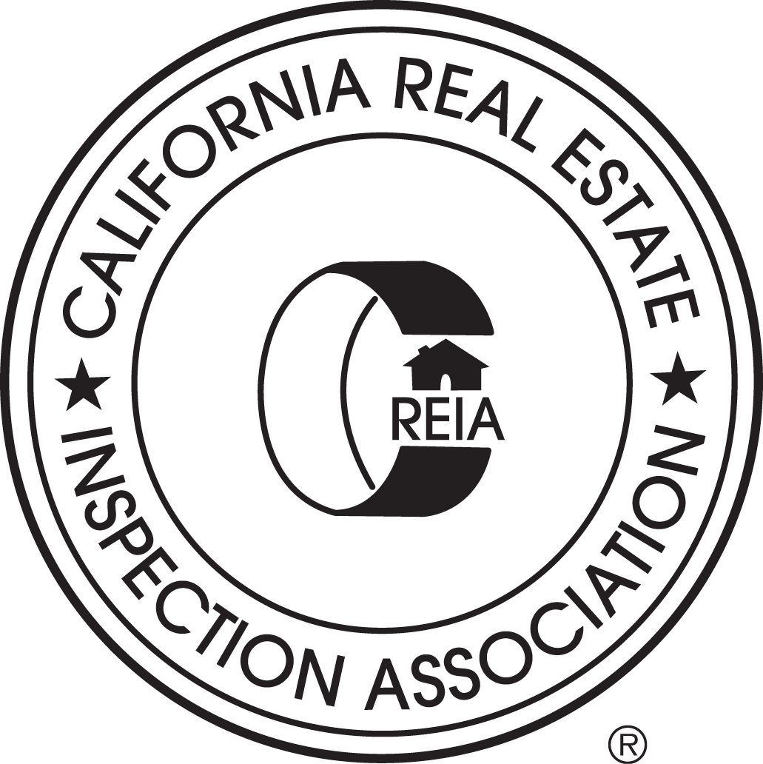2025 CREIA® ALL RIGHTS RESERVED. CREIA® IS A PUBLIC-BENEFIT, NONPROFIT ORGANIZATION

